Tableau Assignment – Visualizing the insights drawn from the Superstore data file.
Step 1 - Importing the dataset into the Tableau

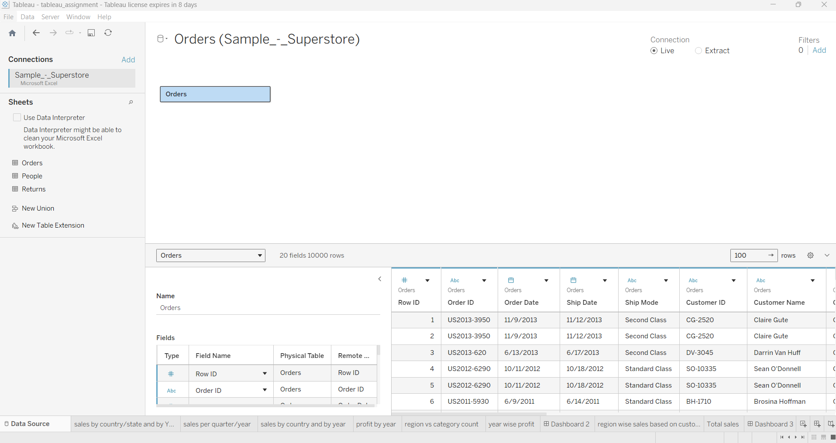

Step 2 – After successfully importing the dataset into the tableau we have made our first analysis of “Sales by country/state per year based on the data available”. The table shows the stats of yearly sales for different states & countries.
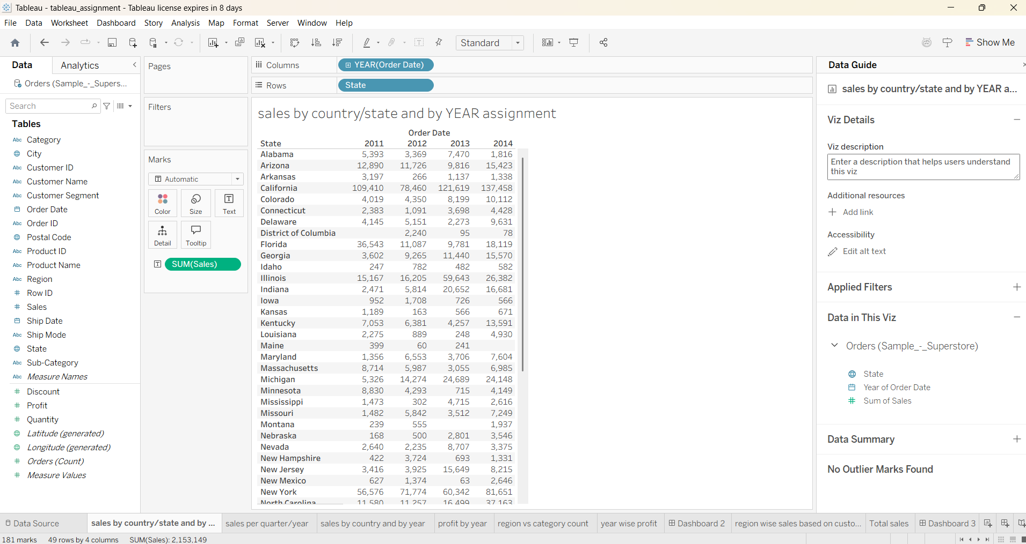
Step 3 – Next we have plotted a graph for different regions quarterly sum of sales. It is showing how the sales is increasing from Q1 to Q4. We have also applied yearly filter so that we can check the trend for desired year.
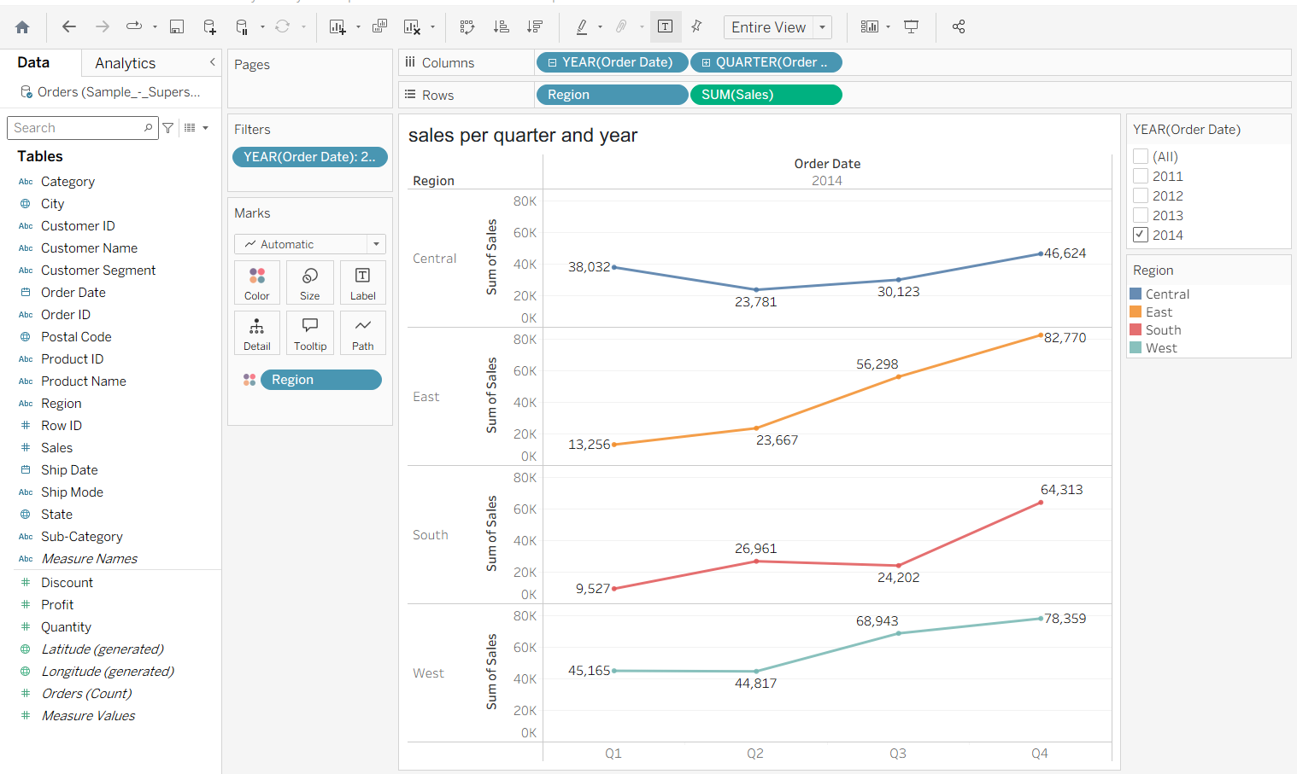
Step 4 – Next we have plotted a line graph showing how sum of sales doing yearly
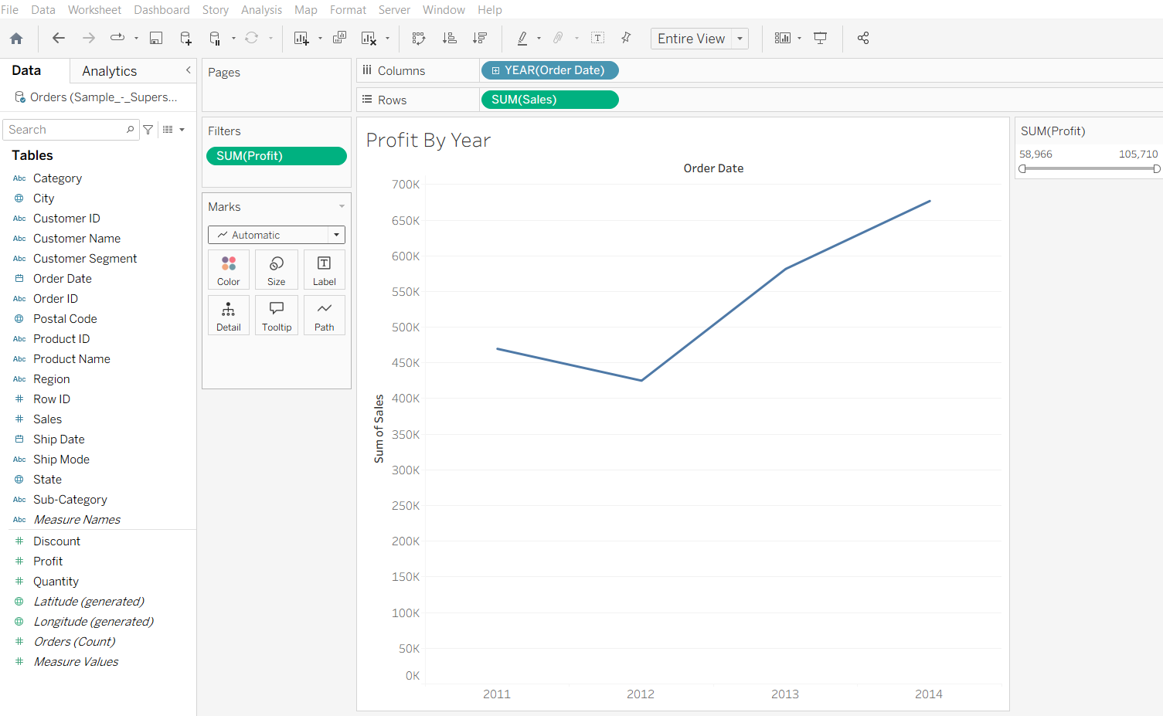Step 5 – Next we have created a table showing region wise product categories sales. How the trend is changing yearly. Which product sales is increasing or decreasing. We can identify the increasing demand of which products.
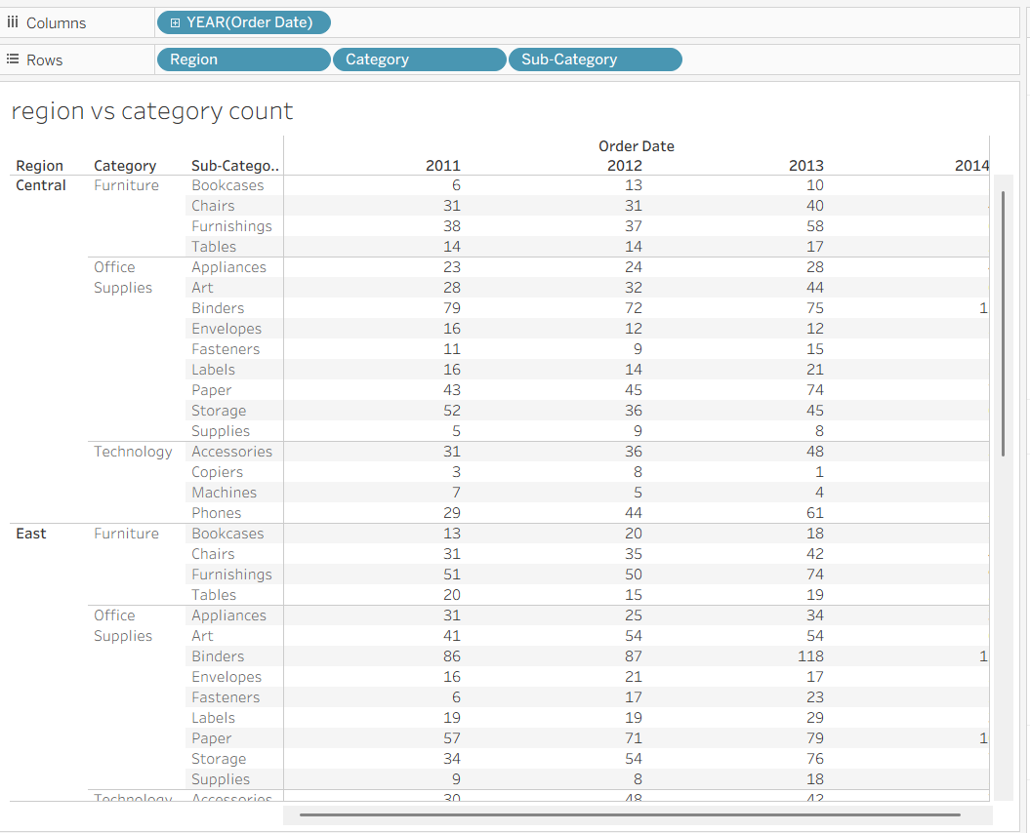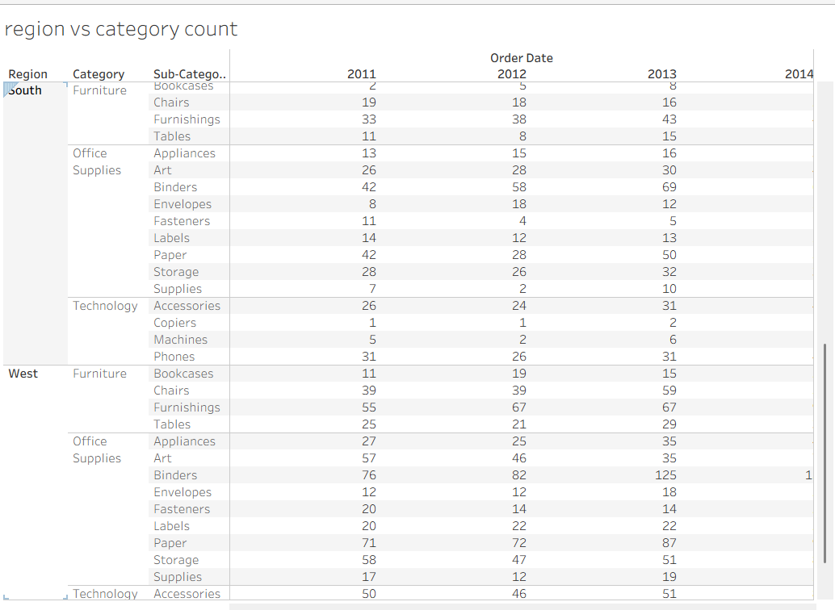

Step 6 - Next we have plotted a graph depicting the sales and profit . how the sales and profit is increasing quarterly and yearly
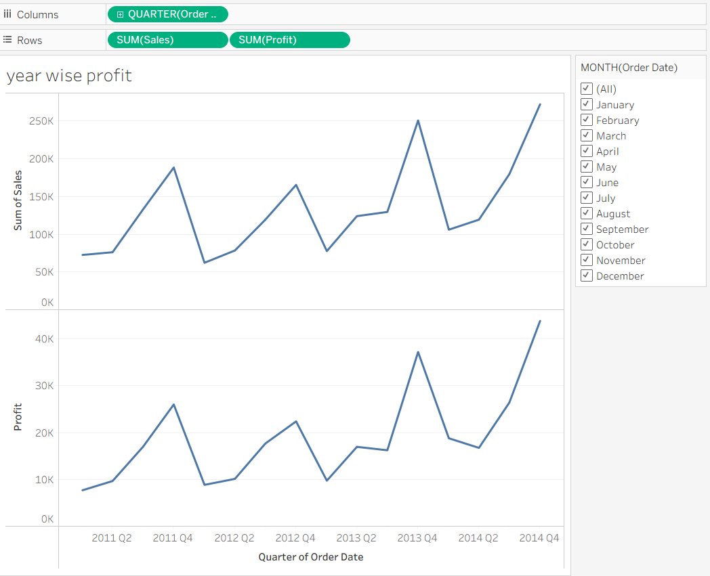

Step 7 - Next we have created our first dashboard which contains more than one type of visualization where we can see the state wise sum of sales, sum of sales graph and quarterly regional sales
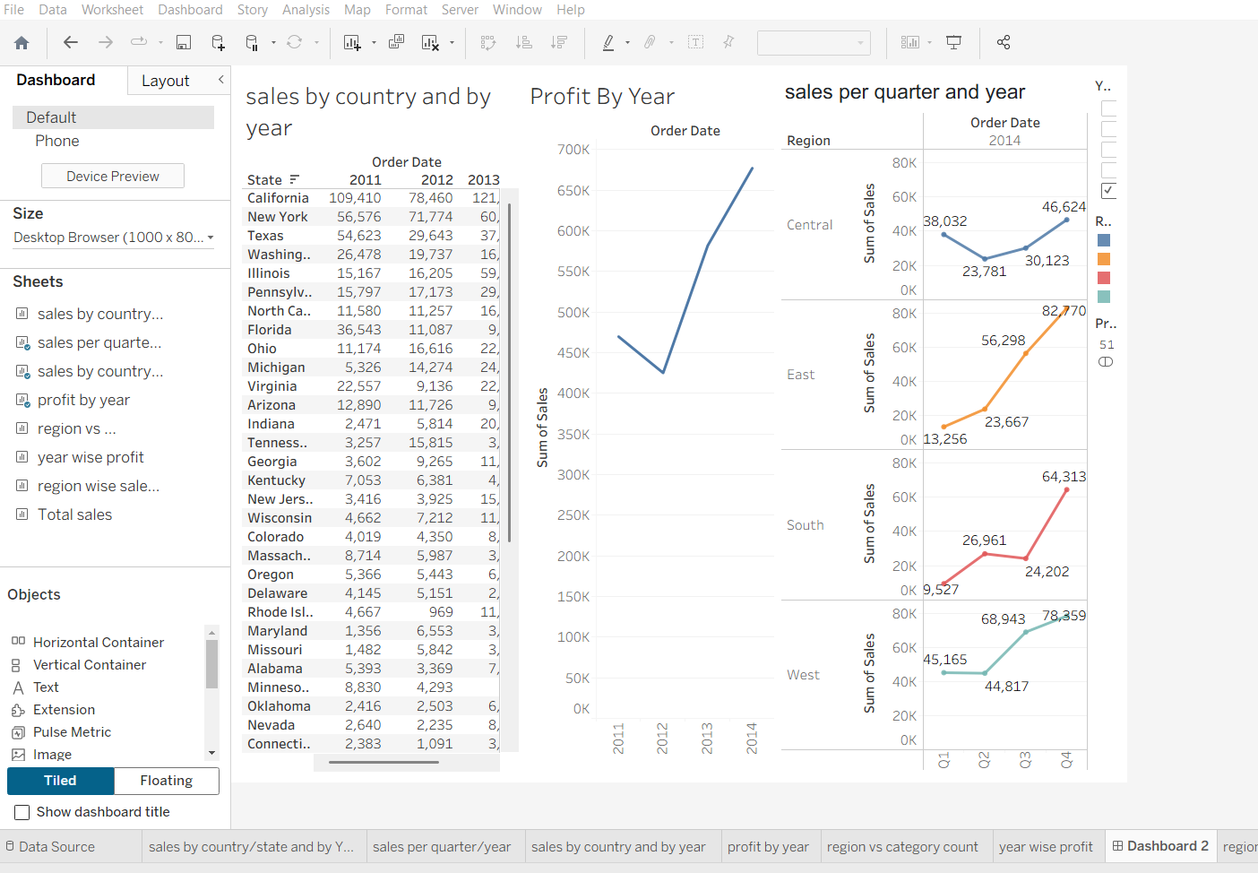

Step 8 – In this step we’ve shown region wise sales of products based on customer segment. From this we can identify what kind of people like to buy which product and what are the profit making segment so that we can help the stores managing their stocks.
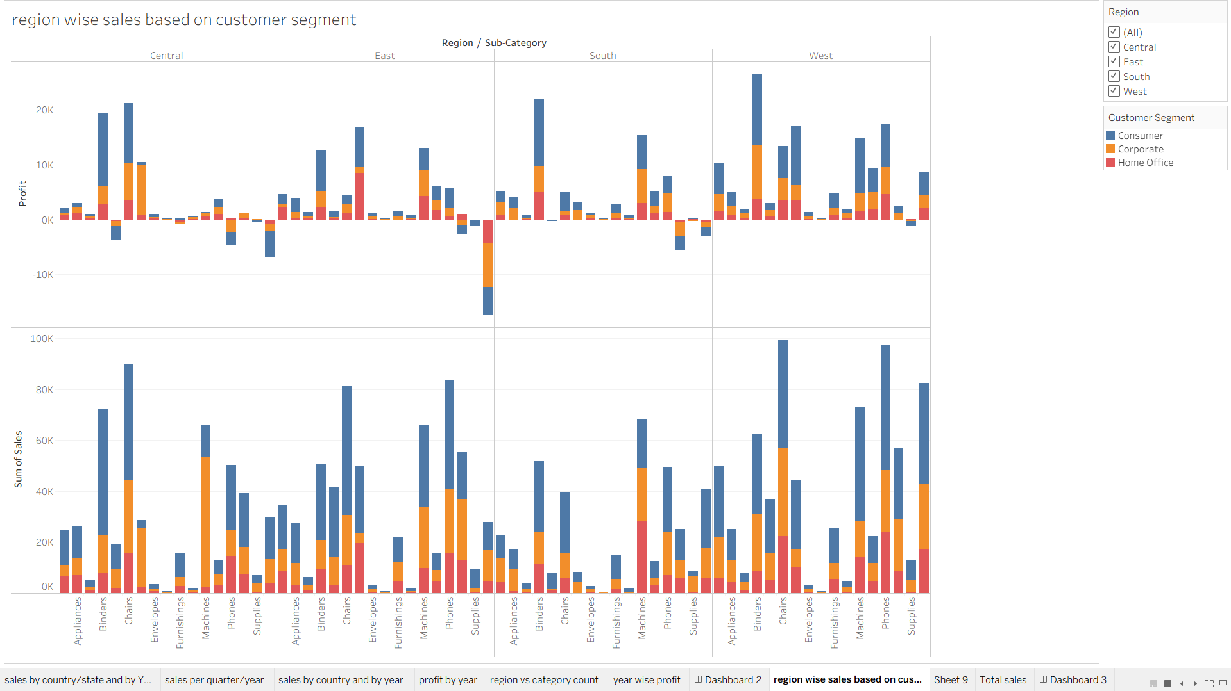

Step 9 – Here we have shown total sales of the products so far and which segment contributes how much to the sales.
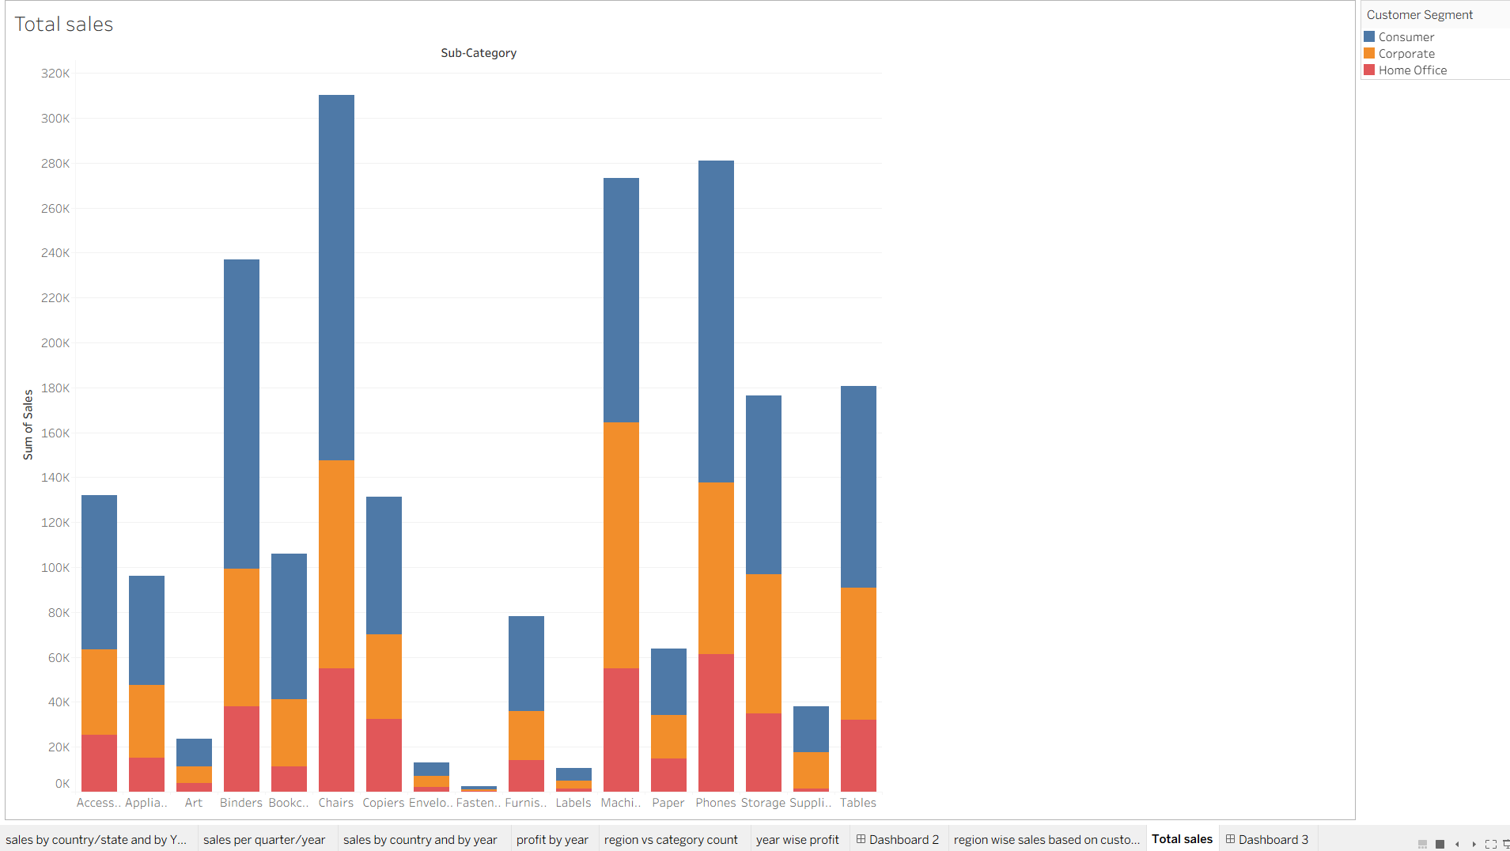

Step 10 - In this step we have created one more dashboard showing the sum of sales yearly and quarterly and total sales product wise. Here we can apply filters if we want to check for particular segment, year etc.
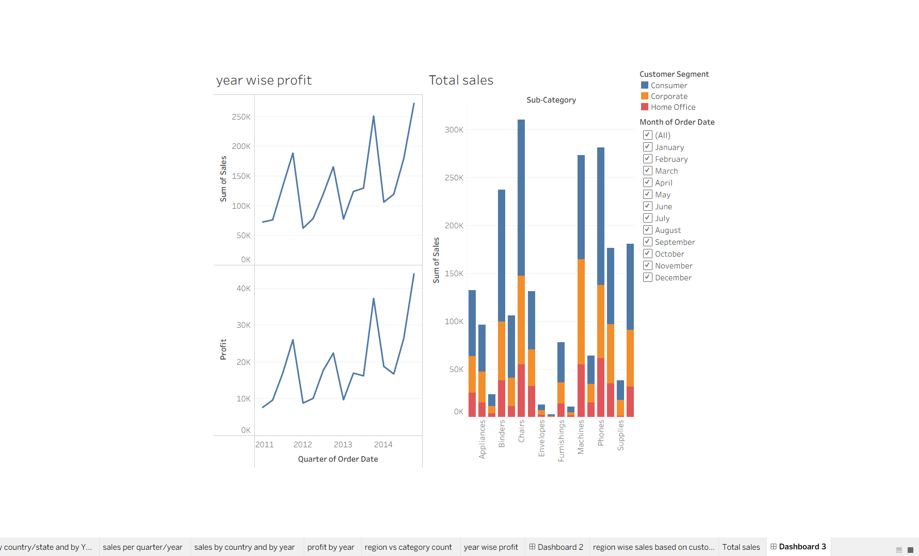

Outcome – In this assignment, we have successfully analyzed the given superstore dataset. We have identified how sales is down in Q1 and how it is increasing in Q4.
We have visualized various graphs showing valuable insights which will help in deriving decisions to make more profits.
We have created dashboards and story.

